

**Introduction to components of a computer system:** Memory, processor, I/O Devices, storage, operating system, Concept of assembler, compiler, interpreter, loader and linker.

**Idea of Algorithm:** Representation of Algorithm, Flowchart, Pseudo code with examples, From algorithms to programs, source code.

**Programming Basics:** Structure of C program, writing and executing the first C program, Syntax and logical errors in compilation, object and executable code. Components of C language. Standard I/O in C , Fundamental data types, Variables and memory locations, Storage classes.

“ PROBLEM SOLVING USING C**”**

**BCA103**

**UNIT-1**

Introduction

Computer is a device which takes data as input, process those data and gives result as output.

Or

Computer is an electronic device used to make calculation and controlling operations expressible in numerical and logical terms.

**Input / Data**

**Process**

**Output / Information**

**Input Devices**

**Processing Devices**

**Output Devices**

**Input Devices**

**CPU**

**Output Devices**

**Input Devices**

**CPU (**ALU + CU + MU**)**

**Output Devices**

Data: Facts and figures are known as Data.

Process: Task to be done on data.

Information: Processed data is known as information.

**Characteristics / Features of Computer**

• **Speed**: The computer can process data very fast, at the rate of millions of instructions per second.

• **Accuracy**: Computer provides a high degree of accuracy. For example, the computer can accurately give the result of division of any two numbers up to 10 decimal places.

• **Diligence**: When used for a longer period of time, the computer does not get tired or fatigued.

• **Storage Capability**: Large volumes of data and information can be stored in the computer and also retrieved whenever required.

• **Versatility**: Computer is versatile in nature. It can perform different types of tasks with the same ease.

**Area / Applications of Computers**

1. Business
2. Healthcare
3. Education
4. Communication
5. Banking
6. Entertainment
7. Science
8. Government
9. Social
10. Navigation
11. Security and surveillance
12. Weather forecasting
13. Robotics
14. Transport
15. Military
16. Retail and trade
17. Publishing
18. Sports
19. Marketing
20. Arts and design

**Classification of Computers**

Computer’s classification can be done on the fallowing basics

**Classification on the basis of data handling signals**

1. **Analogue Computers**
2. **Digital Computers**
3. **Hybrid Computers**
4. **Analogue Computers** is a form of computer that uses the continuously-changeable aspects of electricity. Examples are astrolabe, oscilloscope, television, autopilot, telephone lines, speedometer, etc.
5. **Digital Computers** perform calculations and logical operations with quantities represented as digits, usually in the binary number system of “0” and “1”. digital watches, smart phones, laptop, digital cameras, PDAs, etc are the examples of digital computers.
6. **Hybrid Computers** processes both analog and digital data, Hybrid computer is a digital computer that accepts analog signals, converts them to digital and processes them in digital form. Electrocardiogram or ECG, machine Forensic, patient monitoring system etc are the example for hybrid computers.

**Classification on the basis of size**

1. **Micro computers**
2. **Mini computers**
3. **Mainframe computers**
4. **Super computers**

**Micro computers** A microcomputer, sometimes referred to as a personal computer (PC), is a type of computer that runs on a smaller scale than traditional computers (Personal Computer). A component that is commonly referred to as a motherboard houses the central processing unit (CPU), a microprocessor, memory in the form of ROM (Read Only Memory), RAM (Random Access Memory), I/O ports, and a bus system of connecting wires. They are the most affordable.

**Features of Microcomputers:**

* They are extensively employed for personal usage.
* They are smaller and comparably less expensive.
* Multi-user functionality is not supported.
* It has a limited computational capacity.
* They are quite simple to use.

**Mini computers**

Minicomputers are used by small businesses and industries. They go by the term "Midrange Computers." These minicomputers frequently have several users, just as mainframe computers. They are a bit slower than mainframe computers.

**Features of Minicomputers:**

* It is smaller than mainframes or supercomputers in terms of size.
* In comparison to a mainframe or supercomputer, it is less costly.
* It is able to perform many jobs at once.
* It may be utilized by several users simultaneously.
* It is utilized by small businesses.

**Mainframe computers**

Large corporations and governmental organizations frequently employ mainframe computers to run everyday operations. They have the ability to store and analyze a lot of data. To maintain information on their customers, students, and insurance policyholders, banks, colleges, and insurance companies utilize them. They may also act as a server in a network environment. Hundreds of users may be managed simultaneously by them. Generally 2nd generation computers are known as mainframe computers.

**Mainframe Computer Features:**

* They have enormous amounts of memory.
* They are capable of running several different operating systems.
* They have a significant number of CPUs with powerful processing speeds.
* Tightly Coupled Clustering Technology is employed.

**Super computers**

The most efficient computers in terms of processing data and performance are supercomputers. These computers are used for research and exploratory purposes. Supercomputers are exceedingly large and highly expensive. It can only fit in large, air-conditioned spaces.

Supercomputers are used for a range of tasks, such as space exploration, seismic research, and the testing of nuclear weapons.

**Supercomputer Features:**

* They make use of AI (Artificial intelligence)
* They are the fastest and strongest;
* They are very costly.
* They are enormous in size.
* They are employed by companies that manufacture goods.
* They process information at a rapid rate.

# Computer memory

Computer memory is a device which stores information, such as data and programs, for use in the computer. We can classify them in 2 broad categories.

1. **Volatile Memories-** Memory is computer memory that requires power to maintain the stored information, and the data get lost when the power goes off. Examples for such kind of memories are CPU Registers, Cache Memory and RAMs.
2. **Non-volatile memory-** The memories which doesn’t lost their contents even the power goes off. Examples are ROMs, and all other Secondary storage devices.

A **memory chart** can be use to describe memories as fallows-

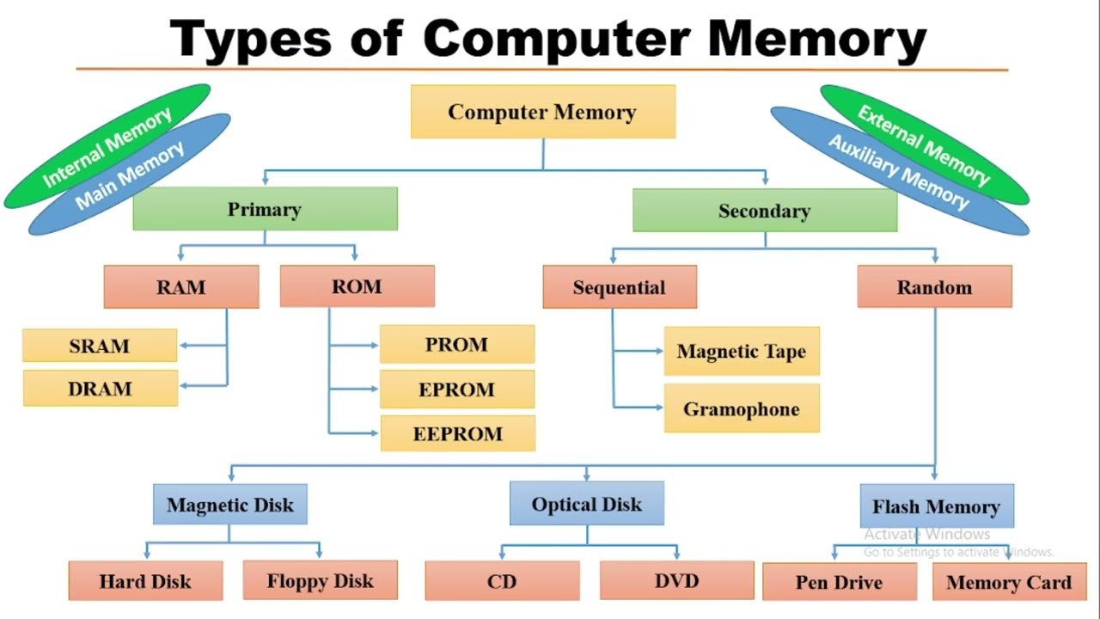

# Processor

A processor or processing unit is an electrical component ([digital circuit](https://en.wikipedia.org/wiki/Circuit_(computer_science))) that performs operations on an external data source, usually [memory](https://en.wikipedia.org/wiki/Memory_(computing)) or some other data stream. It typically takes the form of a microprocessor, which can be implemented on a single or a few tightly integrated [metal–oxide–semiconductor](https://en.wikipedia.org/wiki/Metal%E2%80%93oxide%E2%80%93semiconductor) [integrated circuit](https://en.wikipedia.org/wiki/Integrated_circuit) chips.

**Central Processing Unit (CPU)** A CPU is brain of a computer. It is responsible for all functions and processes. Regarding computing power, the CPU is the most important element of a computer system. The CPU is comprised of three main parts :

***Arithmetic Logic Unit (ALU)*** Executes all arithmetic and logical operations. Arithmetic calculations like as addition, subtraction, multiplication and division. Logical operation like compare numbers, letters, or special characters.

***Control Unit (CU)*** controls and co-ordinates computer components.

1. Read the code for the next instruction to be executed.
2. Increment the program counter so it points to the next instruction.
3. Read whatever data the instruction requires from cells in memory
4. Provide the necessary data to an ALU or register.
5. If the instruction requires an ALU or specialized hardware to complete, instruct the hardware to perform the requested operation.

***Registers*** Stores the data that is to be executed next, "very fast storage area".

CPUs in personal computers are usually also connected, through the motherboard, to a main memory, hard drive or other permanent storage, and [peripherals](https://en.wikipedia.org/wiki/Peripheral), such as a keyboard and [mouse](https://en.wikipedia.org/wiki/Computer_mouse). **Graphics processing units (GPUs)** are present in many computers and designed to efficiently perform computer graphics operations. There are several forms of processors specialized for machine learning. These fall under the category of [AI accelerators](https://en.wikipedia.org/wiki/AI_accelerator) (also known as [**neural processing units**](https://en.wikipedia.org/wiki/Neural_processing_unit)**, or NPUs**) and include [**vision processing units**](https://en.wikipedia.org/wiki/Vision_processing_unit)**(VPUs)** and [**Google**](https://en.wikipedia.org/wiki/Google)**'s**[**Tensor Processing Unit**](https://en.wikipedia.org/wiki/Tensor_Processing_Unit)**(TPU).**

**I/O (Input/Output) Devices**

Input/Output (I/O, i/o, or informally io or IO) is the communication between an information processing system, such as a [computer](https://en.wikipedia.org/wiki/Computer), and the outside world, such as another computer system, peripherals, or a human operator. [Inputs](https://en.wikipedia.org/wiki/Information) are the signals or data received by the system and outputs are the signals or [data](https://en.wikipedia.org/wiki/Data_(computing)) sent from it.

**I/O devices** are the pieces of [hardware](https://en.wikipedia.org/wiki/Hardware_(computing)) used by a human (or other system) to communicate with a computer. For instance, a [keyboard](https://en.wikipedia.org/wiki/Computer_keyboard) or [computer mouse](https://en.wikipedia.org/wiki/Computer_mouse) is an [input device](https://en.wikipedia.org/wiki/Input_device) for a computer, while [monitors](https://en.wikipedia.org/wiki/Computer_monitor) and [printers](https://en.wikipedia.org/wiki/Computer_printer) are [output devices](https://en.wikipedia.org/wiki/Output_device). Devices for communication between computers, such as [modems](https://en.wikipedia.org/wiki/Modem) and [network cards](https://en.wikipedia.org/wiki/Network_card), typically perform both input and output operations. Any interaction with the system by an interactor is an [input](https://en.wikipedia.org/wiki/Input_(computer_science)) and the reaction the system responds is called the output.

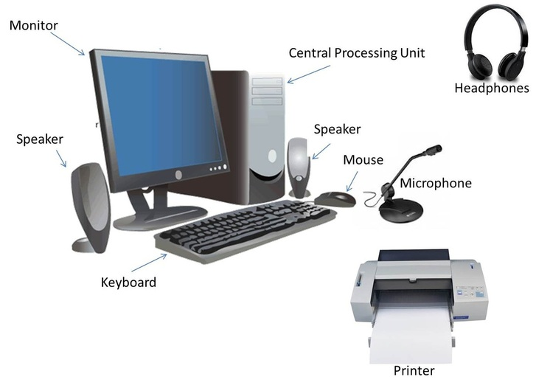

**Input Devices**

Input device is any peripheral (piece of computer hardware equipment to provide data and control signals to an information processing system such as a computer or other information appliance. Input device Translate data from form that humans understand to one that the computer can work with. Most common are keyboard and mouse.

*Example of Input Devices:-*

1. Keyboard
2. Mouse (pointing device)
3. Microphone
4. Touch screen
5. Scanner
6. Webcam
7. Touchpads
8. MIDI keyboard
9. JoyStick
10. Graphics Tablets
11. Cameras
12. Pen Input
13. Video Capture Hardware
14. Microphone
15. Trackballs
16. Digital camera
17. Gamepad
18. Electronic Whiteboard
19. Optical Mark Reader
20. Optical Character Recognition
21. Magnetic Ink Character Reader
22. Bar Code Reader
23. Finger Print scanner
24. Eye Scanners

## ****Keyboard****

For entering data into a [computer](https://www.geeksforgeeks.org/basics-of-computer-and-its-operations/), the keyboard is the most common and commonly used input device. It contains various keys for entering letters, numbers, and characters. Although there are some additional keys for completing various activities, the keyboard layout is identical to that of a standard typewriter. It is generally available in two different sizes 84 keys or 101/102 keys and for Windows and the Internet, it is also available with 104 keys or 108 keys. It is connected to a computer system with the help of a [USB](https://www.geeksforgeeks.org/universal-serial-bus-usb-in-computer-network/) or a [Bluetooth device](https://www.geeksforgeeks.org/bluetooth/).

The keys on the keyboard are

* **Numeric Keys:**These keys are used to enter numeric data and move the cursor. It is typically made up of 17 keys.
* **Alphabet Keys:** These keys include the letter keys (A-Z) and the number keys (09).
* **Control Keys:** The pointer and the screen are controlled by these keys. It comes with four directional arrow keys. Control keys include Home, End, Insert, Alternate(Alt), Delete, Control(Ctrl), and Escape.
* **Special Keys:**Enter, Shift, Caps Lock, NumLk, Tab, and Print Screen are some of the special function keys on the keyboard.
* **Function Keys:** The 12 keys from F1 to F12 are on the topmost row of the keyboard.

Generally, the keyboard is of three types:

* [QWERTY Keyboard](https://www.geeksforgeeks.org/qwerty-best-or-worst-keyboard-layout/)
* AZERTY Keyboard
* DVORAK Keyboard

**Characteristics of Keyboard**

* The keyboard has various functions keys for a different purpose
* Instead of using the mouse, we can utilize the arrow keys on the keyboard to do the same purpose as the mouse.
* The main keyboard, cursor keys, numeric keypad, and function keys are the four primary components of a keyboard.
* Keyboards are more affordable.

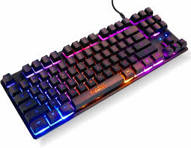

## ****Mouse****

The mouse is the most used pointing device. While clicking and dragging, the mouse moves a little cursor across the screen. If you let off of the mouse, the cursor will come to a halt. You must move the mouse for the computer to move; it will not move on its own. As a result, it’s a device that accepts input. Or we can say that a mouse is an input device that allows you to control the coordinates and movement of the on-screen cursor/pointer by moving the mouse on a flat surface. The left mouse button can be used to pick or move items, while the right mouse button displays additional menus when clicked. It was invented in 1963 by Douglas C. Engelbart.

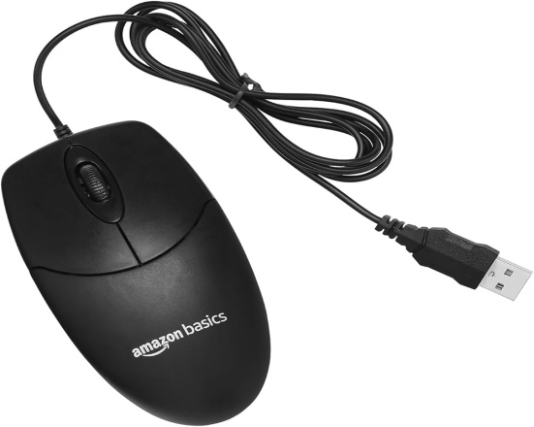Generally, the mouse is of four types

* Trackball Mouse
* Mechanical Mouse
* Optical Mouse
* Wireless Mouse

### ****Characterics****

* A mouse is used to move the cursor on the screen in the desired direction.
* A mouse allows users to choose files, folders, or multiple files or text or, all at once.
* Hover over any object with the mouse pointer.
* A mouse can be used to open a file, folder, etc. You must first move your pointer to a file, folder, and then double-click on it to open or execute.

## ****Joystick****

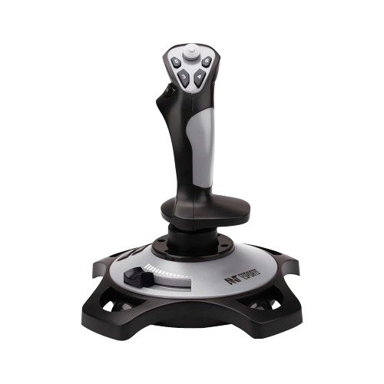A pointing device used to move the cursor around the screen is the joystick. Both the bottom and top ends of the stick have a spherical ball affixed to them. A socket contains the lower spherical ball. You can adjust the joystick in all directions. Trackballs became quite popular in laptops and PCs since they fit neatly inside the case and take up less room when in use. They are more precise and long-lasting than a mouse, which is why they are still utilized. It is invented by C.B.Mirick.

### ****Characteristics****

* It’s utilized to regulate the cursor’s position across a display screen.
* It’s utilized in computer games to move the characters and symbols around.
* It commonly features one or more push buttons, the condition of which can be controlled by the computer as well.

## ****Light Pen****

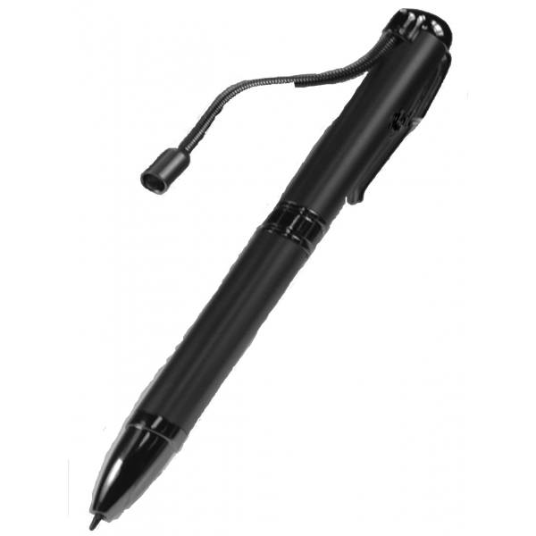A light pen is a pointing device that has the appearance of a pen. It can be used to draw on the monitor screen or to pick a menu item. In a small tube, a photocell and an optical system are housed. The photocell sensor element determines the screen location and sends a signal to the CPU when the tip of a light pen is moved across a monitor screen while the pen button is pressed.

### ****Characteristics****

* When drawing graphics, a light pen comes in very handy.
* Objects on the display screen are selected with a light pen.

## ****Scanner****

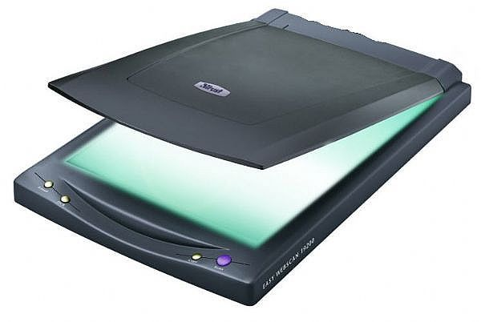A scanner is a type of input device that works in the same way as a photocopier. It’s used when there’s data on paper that needs to be transferred to the computer’s [hard disc](https://www.geeksforgeeks.org/hard-disk-drive-hdd-secondary-memory/) for further processing. The scanner collects images from the source and translates them to a digital version that can be saved on the hard disks. These graphics can be changed before they are printed.

Generally, the scanner is of five types:

* Flatbed Scanner
* Handheld Scanner
* Sheetfed Scanner
* Drum Scanner
* Photo Scanner

### ****Characteristics****

* You can scan film negatives via a scanner if there is a transparent media adaptor.
* A scanner may also scan low-quality or non-standard-weight paper.
* The scanners are adaptable, allowing you to scan a wide range of items regardless of their size. You can scan small items as well as large documents if you can locate them.

## ****OCR****

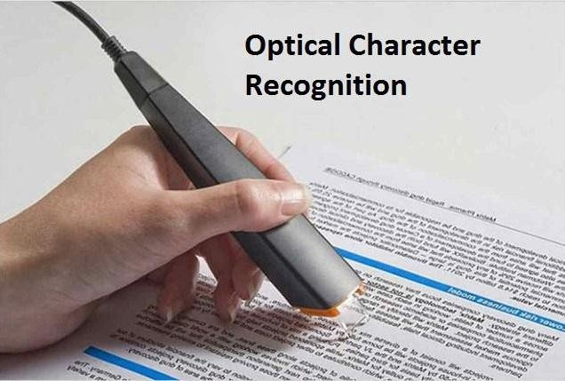OCR stands for [Optical Character Recognition](https://www.geeksforgeeks.org/advantages-and-disadvantages-of-optical-character-reader-ocr/) in its full form. OCR is a computer reading technique that reads numbers, characters, and symbols. OCR is a technique for recognizing text in documents that have been scanned into digital form. Optical character recognition (OCR) refers to a device that reads printed text. Character by character, OCR scans the text, converts it to a machine-readable code, and saves it into the memory of the system. OCR also functions as a scanner, scanning documents, photos, images, and handwritten text and storing the information in memory, which may then be compared to previously stored data.

### ****Characteristics****

* The technology offers a complete solution for form processing and document capture.
* It has capabilities for defining shapes, scanning, image pre-processing, and identification.

## ****Barcode Reader****

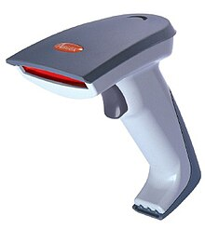A bar code reader is a device that reads bar-coded data (data that is represented by light and dark lines). To label things, number books, and so on, bar-coded data is often utilized. It could be a standalone scanner or a component of one. A barcode reader is a device that reads barcodes and extracts data from them. The code bar is used to read the bar code printed on any goods. By impacting light beams on barcode lines, a barcode reader identifies existing data in barcodes.

### ****Characteristics****

* When a card is inserted, auto-start barcode scanners begin scanning immediately.
* Reading indicators give the user confirms that the card has been swiped correctly.
* It’s simple to use, simply hold your phone up to the code and scan it.

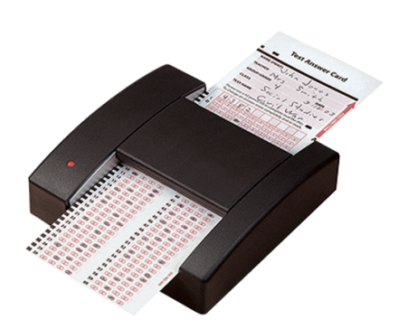**OMR**

which stands for optical mark reading or optical mark recognition, is the process of getting data from people by identifying marks on a paper. On a document or specifically printed papers used in exams, surveys, etc., OMR can identify marks made by people. It is typically utilized in situations where a lot of candidates apply and data needs to be processed quickly and accurately. Using an OMR reader, data is extracted from the document.

## MICR

The full form of MICR is **Magnetic Ink Character Recognition**. MICR code (Magnetic Ink Character Recognition Code) is a pattern recognition system used mostly by the bank industry to identify the document’s originality and to enable the processing and approval of cheques and other papers. It is a technology that is used with the help of specific characters and ink of magnetic oxide.

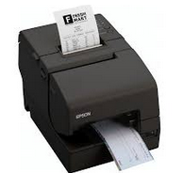A MICR code is a nine-digit code that recognises the bank and branch involved in an ECS (Electronic Clearing System) uniquely. The MICR code is written next to the cheque number at the base of a cheque leaf. It can also be found printed on the very first page of a bank savings account passbook.

**Braille keyboard**

A Braille keyboard is specifically designed for individuals who are blind or have low vision. It allows users to input text using Braille characters, which can be read by touch.

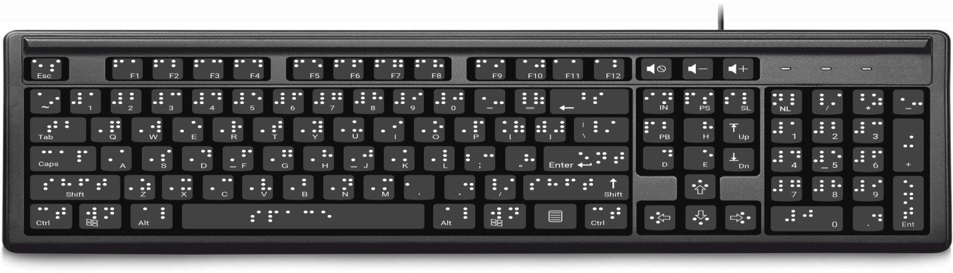

**Output Devices**

An output device is any piece of computer hardware equipment used to communicate the results of data processing carried out by an information processing system (such as a computer) which converts the electronically generated information into human readable form.

## Different Types of Output Devices

The various output devices are as below:

### 1. Monitor / VDU (Visual Display Unit)

A computer’s principal output device is a monitor, often known as a [visual display unit (VDU)](https://www.geeksforgeeks.org/what-is-vduvisible-display-unit/). It displays the processed data like text, images, videos, audios, etc. It makes images by arranging microscopic dots in a rectangular pattern, known as pixels. The sharpness of an image is determined by the number of pixels.

**Characteristics of Monitor:**

* **Resolution pixels:** Pixels are the smallest element of any image, while number of Horizontal dots vs Number of vertical dots makes any monitor’s aspect ratio.
* **Size:** The size of the monitor is diagonal measurement of a desktop screen 14 to 25 inches.
* **Refresh Rate:** Total number of times per second that an image on a display is repainted or refreshed.

*Basic types of monitors are*

* A. Cathode Ray Tube (CRT).
* B. Thin Film Transistor (TFT)
* B. Liquid Crystal Displays (LCD).
* C. light-emitting diode (LED).

**2. Printer**

Printers are information output devices that allow you to print data on paper. Or in other words, it is an output device that creates a hard copy of the processed data or information. Printers are divided into two categories:

* **Impact Printer:**In impact printers, characters are printed on the ribbon, which is then smashed on the paper. Here to print the paper the hammer or print head strikes an ink ribbon against the paper and the character starts printing. Some of the types of impact printers are:
  + Dot matrix printer
  + Daisy wheel printer
  + Line printer
  + Chain printer
* **Characteristics:**
  + Extremely low consumable costs.
  + Fairly noisy
  + It’s perfect for large-scale printing because of its inexpensive cost.
  + Physical contact with the paper is required to form an image.
* **Non-Impact Printers:**Non-impact printers print characters without the use of a ribbon. These printers are often known as page printers because they print a full page at a time. Some of the types of non-impact printers are:
  + Laser printer
  + Inkjet printer
* **Characteristics:**
  + Quicker.
  + They don’t produce much noise.
  + Superior quality.
  + Supports a wide range of fonts and character sizes.

**3. Plotter**

A plotter is a device that prints high-quality graphics in a variety of color formats. It works in a similar way to a printer, although it has more advanced features. It is used to print large maps, architectural drawings, large-format printing, and create pictures, 3D postcards, advertising signs, charts, and various designs of the internal structure of building, machines etc.

**4. Projector**

A projector is a device that allows users to project their output onto a large area, such as a screen or a wall. It can be used to project the output of a computer and other devices onto a screen. It magnifies texts, photos, and movies using light and lenses. As a result, it’s an excellent output device for giving presentations or teaching big groups of people.

### 5. Speakers

[Speakers](https://www.geeksforgeeks.org/speakers/) are connected to computers to allow sound to be output. For the working of speakers, sound cards are required. From simple two-speaker output devices to surround-sound multi-channel sets, speakers come in a variety of shapes and sizes. They take audio input from the computer’s sound card and output sound waves as audio output.

# Storage

Alternatively called **digital storage**, **storage**, **storage media**, or **storage medium**, a **storage device** is any [hardware](https://www.computerhope.com/jargon/h/hardware.htm) capable of holding information either temporarily or permanently.Two types of storage devices are used with computers: a [primary storage](https://www.computerhope.com/jargon/p/primstor.htm) device, such as [RAM](https://www.computerhope.com/jargon/r/ram.htm) (Random-Access Memory), and a [secondary storage](https://www.computerhope.com/jargon/s/secostor.htm) device, such as a [hard drive](https://www.computerhope.com/jargon/h/harddriv.htm). Secondary storage can be [removable](https://www.computerhope.com/jargon/r/remodisk.htm), [internal](https://www.computerhope.com/jargon/i/internal.htm), or [external](https://www.computerhope.com/jargon/e/external.htm).

**Primary Memory**

**1. RAM** **(Random Access Memory) RAM** is a memory scheme within the computer system responsible for storing data on a temporary basis, so that it can be promptly accessed by the processor as and when needed. It is volatile in nature, which means that data will be erased once supply to the storage device is turned off. It can be of 2 types:

**a. SRAM (Static Ram)-** It’s made up of flip-flops and also known as Cache memory of computers. It doesn’t need refresh again and again and make computer faster by storing the data which has to be used frequently.

**b. DRAM (Dynamic Ram)-** It is also known as main memory of computers and use to store Operating System, currently running programs and other data. It needs to be refreshed frequently and also known as Main memory of computer.

**2. ROM** **(Read Only Memory) ROM** is a permanent form of storage. ROM stays active regardless of whether power supply to it is turned on or off. ROM devices do not allow data stored on them to be modified. They can be classified into fallowing types-

**a. MROM (Masked Read Only Memory)-** It’s Hard Wired ROM.

**b. PROM (Programable Read Only Memory)-** Can be writable only once.

**c. EPROM (Erasable Programable Read Only Memory)-** Can be re-writable, but once anyone try to re-write then the whole data stored earlier get lost.

**d. EEPROM (Erasable Erasable Programable Read Only Memory)-** Can be rewrite at any location, and any chunks of data without the previously data being lost.

**Secondary** Memory Stores data and programs permanently. data retained after the power is turned off

**1. Hard drive (HD)** A hard disk is part of a unit, often called a "disk drive," "hard drive," or "hard disk drive," that store and provides relatively quick access to large amounts of data on an electromagnetically charged surface or set of surfaces.

**2. Optical Disk** an optical disc drive (ODD) is a disk drive that uses laser light as part of the process of reading or writing data to or from optical discs. Some drives can only read from discs, but recent drives are commonly both readers and recorders, also called burners or writers. Compact discs, DVDs, and Blu-ray discs are common types of optical media which can be read and recorded by such drives. Optical drive is the generic name; drives are usually described as "CD" "DVD", or "Bluray", followed by "drive", "writer", etc. There are three main types of optical media: CD, DVD, and Blu-ray disc. CDs can store up to 700 megabytes (MB) of data and DVDs can store up to 8.4 GB of data. Blu-ray discs, which are the newest type of optical media, can store up to 50 GB of data. This storage capacity is a clear advantage over the floppy disk storage media (a magnetic media), which only has a capacity of 1.44 MB.

**3. Flash Disk** A storage module made of flash memory chips. A Flash disks have no mechanical platters or access arms, but the term "disk" is used because the data are accessed as if they were on a hard drive. The disk storage structure is emulated.

### 4. Online and cloud

Storing data online and in cloud storage is becoming popular as people need to access their data from multiple devices.

* [Cloud storage](https://www.computerhope.com/jargon/c/cloudcom.htm)
* [Network media](https://www.computerhope.com/jargon/n/network-media.htm)

**Operating System**

O/S are system software. It basically manages all the resources of the computer. An operating system acts as an interface between the software and different parts of the computer or the computer hardware. It controls and monitors the execution of all other programs that reside in the computer, which also includes application programs and other system software of the computer. Examples of Operating Systems are *DOS, UNIX Windows, Linux, Mac OS*, etc.

## Functions of Operating System

### ****1. Memory Management****

It is the management of the main or primary memory. Whatever program is executed, it has to be present in the main memory. The operating system:

* Allocates and deallocates the memory.
* Keeps a record of which part of primary memory is used by whom and how much.
* Distributes the memory while multiprocessing.
* In multiprogramming, the operating system selects which processes acquire memory when and how much memory they get.

### ****2. Processor Management/Scheduling****

Every software that runs on a computer is a process. The OS:

* Allocates and deallocates processor to the processes.
* Keeps record of CPU status.

Certain algorithms used for CPU scheduling are as follows:

* First Come First Serve (FCFS)
* Shortest Job First (SJF)
* Round-Robin Scheduling
* Priority-based scheduling etc.

The purpose of CPU scheduling is as follows:

* Proper utilization of CPU. Since the proper utilization of the CPU is necessary.
* The OS makes sure that the devices get fair processor time.
* Increasing the efficiency of the system.

### ****3. Device Management****

An operating system regulates device connection using drivers. The OS:

* Allocates and deallocates devices to different processes.
* Keeps records of the devices.
* Decides which process can use which device for how much time.

### ****4. File Management****

The operating system manages resource allocation and de-allocation. The OS:

* Keeps records of the status and locations of files.
* Allocates and deallocates resources.
* Decides who gets the resources.

### ****5. Storage Management****

The OS uses storage management for:

* Improving the performance of the data storage resources.
* It optimizes the use of various storage devices.
* Assists businesses in storing more data on existing hardware, speeding up the data retrieval process, preventing data loss, meeting data retention regulations, and lowering it costs.